**Risk Management w.r.t. NP Hard analysis:**

1. In appropriate dataset -To overcome this risk we are trying to use well organized and complete dataset.
2. Security- To overcome and improving security we use multilevel security like access permissions of user.

**Risk Identification:**

1. Have top software and customer managers formally committed to support the project?

Ans-Not apllicaable.

2. Are end-users enthusiastically committed to the project and the system/product

to be built?

Ans-Not known at this time.

3. Are requirements fully understood by the software engineering team and its

customers?

Ans-Yes

4. Have customers been involved fully in the definition of requirements?

Ans-Not applicable

5. Do end-users have realistic expectations?

Ans-Not applicable

6. Does the software engineering team have the right mix of skills?

Ans-yes

7. Are project requirements stable?

Ans-Not applicable

8. Is the number of people on the project team adequate to do the job?

Ans-Not applicble

9. Do all customer/user constituencies agree on the importance of the project and

on the requirements for the system/product to be built?

Ans-Not applicable

**Risk Analysis:**

The risks for the Project can be analyzed within the constraints of time and quality

**Risk Table:**

|  |  |  |  |  |  |
| --- | --- | --- | --- | --- | --- |
| ID | Risk Description | Probability | Schedule | Quality | Overall |
| 1 | correctness | low | Low | high | Low |
| 2 | Availability | high | Low | high | high |

**Risk Probability definitions:**

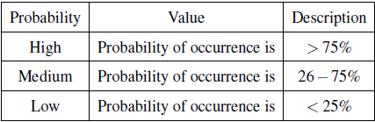

**Risk Impact definitions:**

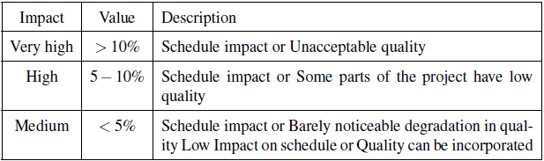

**Risk Mitigation Risk Monitoring and Risk Management**

**1. Risk Mitigation:**

If a software team adopts a proactive approach to risk, avoidance is always the best strategy. This is achieved by developing a plan for *risk mitigation.* To mitigate this risk, you would develop a strategy for reducing turnover. Among the possible steps to be taken are:

• Meet with current staff to determine causes for turnover (e.g., poor working conditions, low pay, competitive job market).

• Mitigate those causes that are under your control before the project starts.

• Once the project commences, assume turnover will occur and develop techniques to ensure continuity when people leave.

• Organize project teams so that information about each development activity is widely dispersed.

• Define work product standards and establish mechanisms to be sure that all models and documents are developed in a timely manner.

• Conduct peer reviews of all work (so that more than one person is “up to speed”).

• Assign a backup staff member for every critical technologist.

**2. Risk Monitoring**

As the project proceeds, *risk-monitoring* activities commence. The project manager monitors factors that may provide an indication of whether the risk is becoming more or less likely. In the case of high staff turnover, the general attitude of team members based on project pressures, the degree to which the team has jelled, interpersonal relationships among team members, potential problems with compensation and benefits, and the availability of jobs within the company and outside it are all monitored.

**3. Risk Management**

*Risk management and contingency planning* assumes that mitigation efforts have failed and that the risk has become a reality. Continuing the example, the project is well under way and a number of people announce that they will be leaving. If the mitigation strategy has been followed, backup is available, information is documented, and knowledge has been dispersed across the team. In addition, you can temporarily refocus resources (and readjust the project schedule) to those functions that are fully staffed, enabling newcomers who must be added to the team to “get up to speed.” Those individuals who are leaving are asked to stop all work and spend their last weeks in “knowledge transfer mode.” This might include video-based knowledge capture, the development of “commentary documents or Wikis,” and/or meeting with other team members who will remain on the project.